## Cutpoints And Bridges

Cutpoints in a graph refer to vertices whose removal would increase the number of components in the network. They are significant when analyzing the flow of a network, as their removal affects the connectivity of the graph. Cutpoints often occupy crucial positions, connecting different parts of the network. In the case of the undirected working network, a weak component rule is applied to identify cutpoints, given the network's low density.

**Working Network**

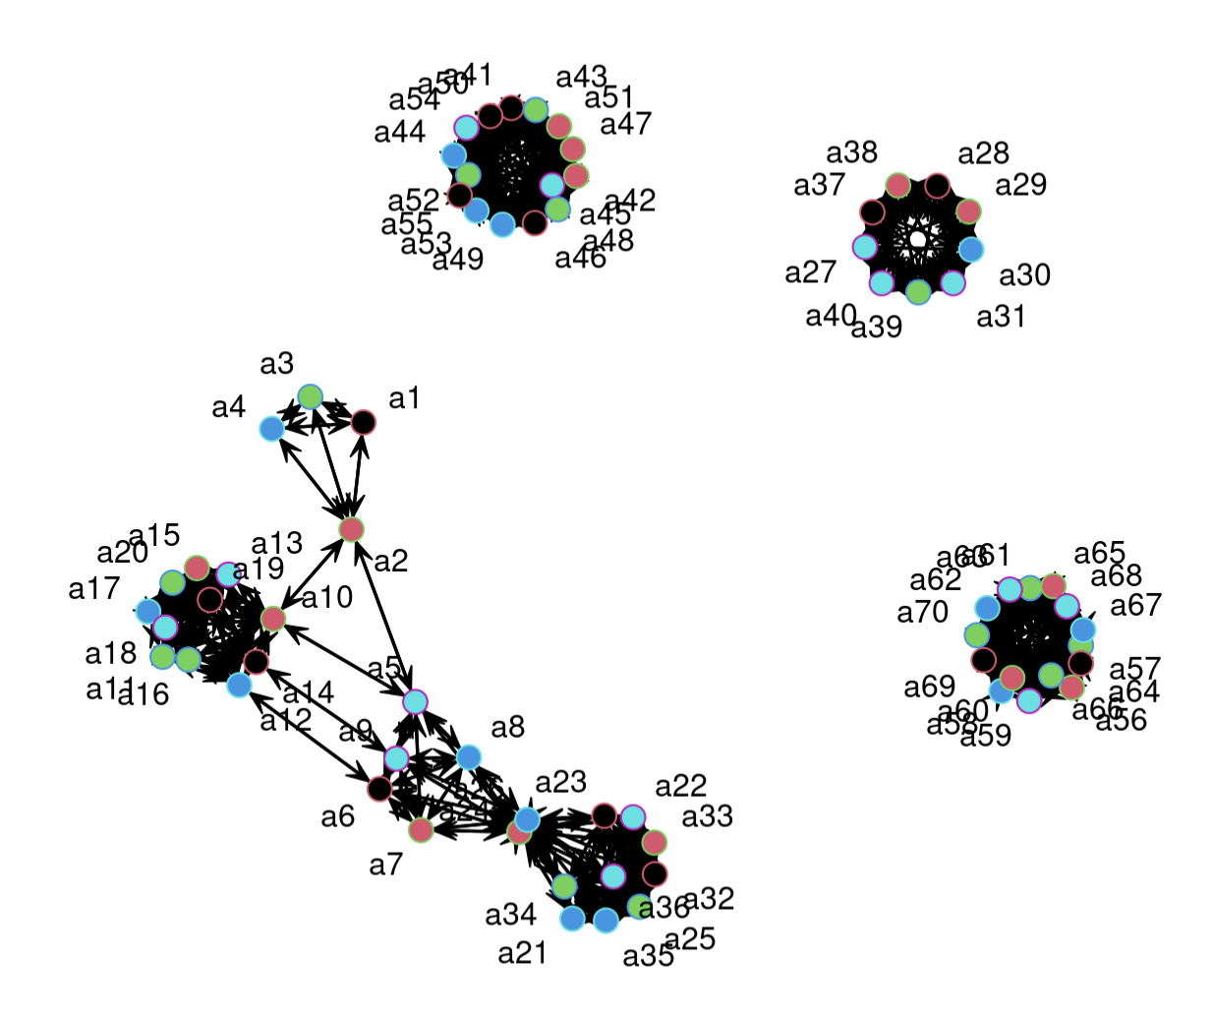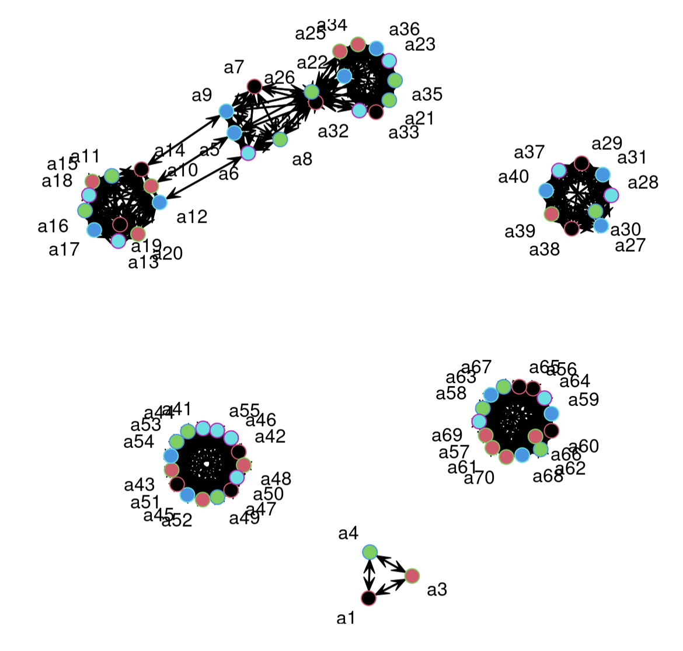

The Working network has only one cutpoint as it has clusters of highly connected nodes. The figures above show how the removal of the cutpoint ‘a2’ leads to the isolation of the a1-a4-a3 subgroup.

**Friendship Network**

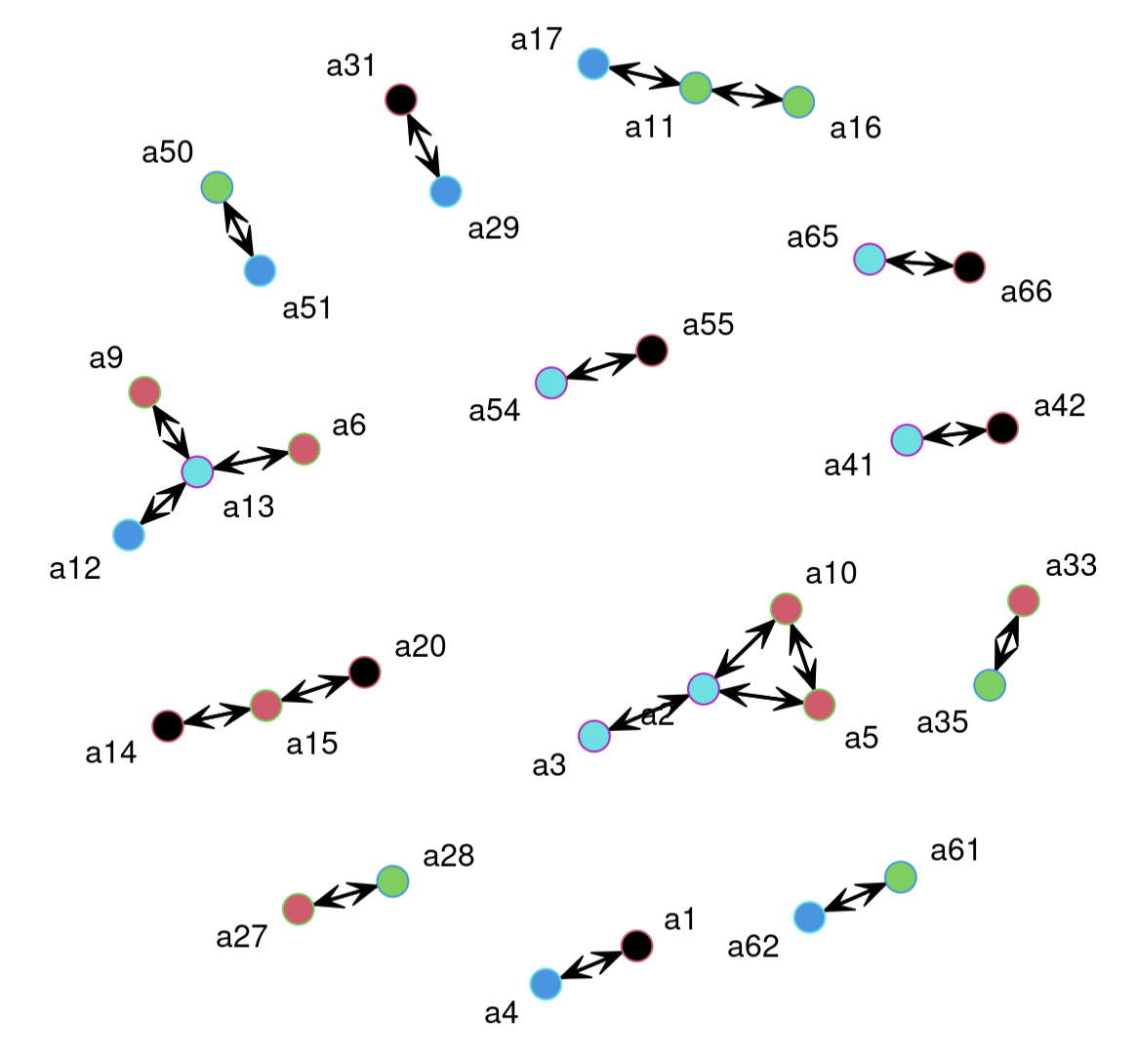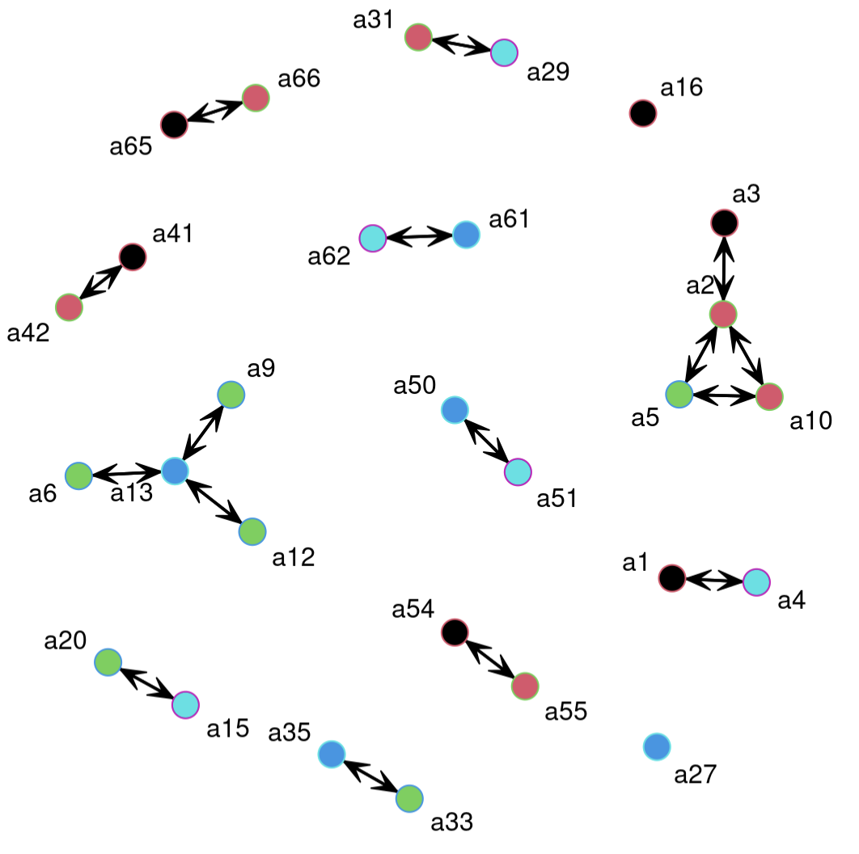

With the Friendship network, there are far more dyads to be broken up into isolates. In this network, there were 4 cutpoints identified and removed. Because this network is even less dense than the working network, the cutpoints do not show a significant change in the overall structure, however, it can be seen how some triads are broken up leading to identification of brokerages between friendships.

**Advice Network**

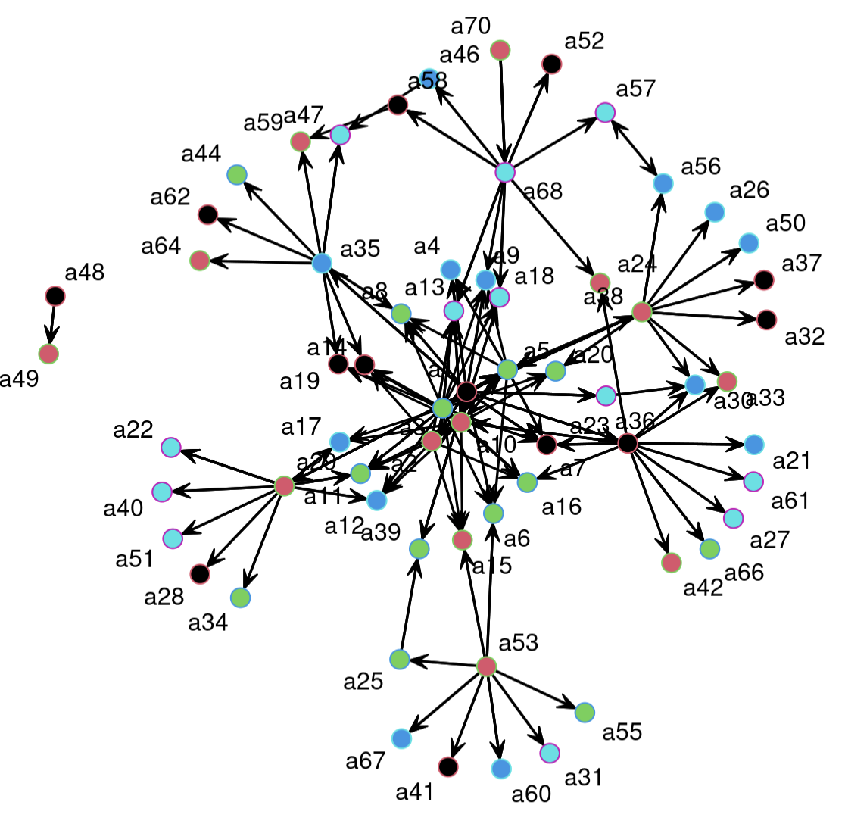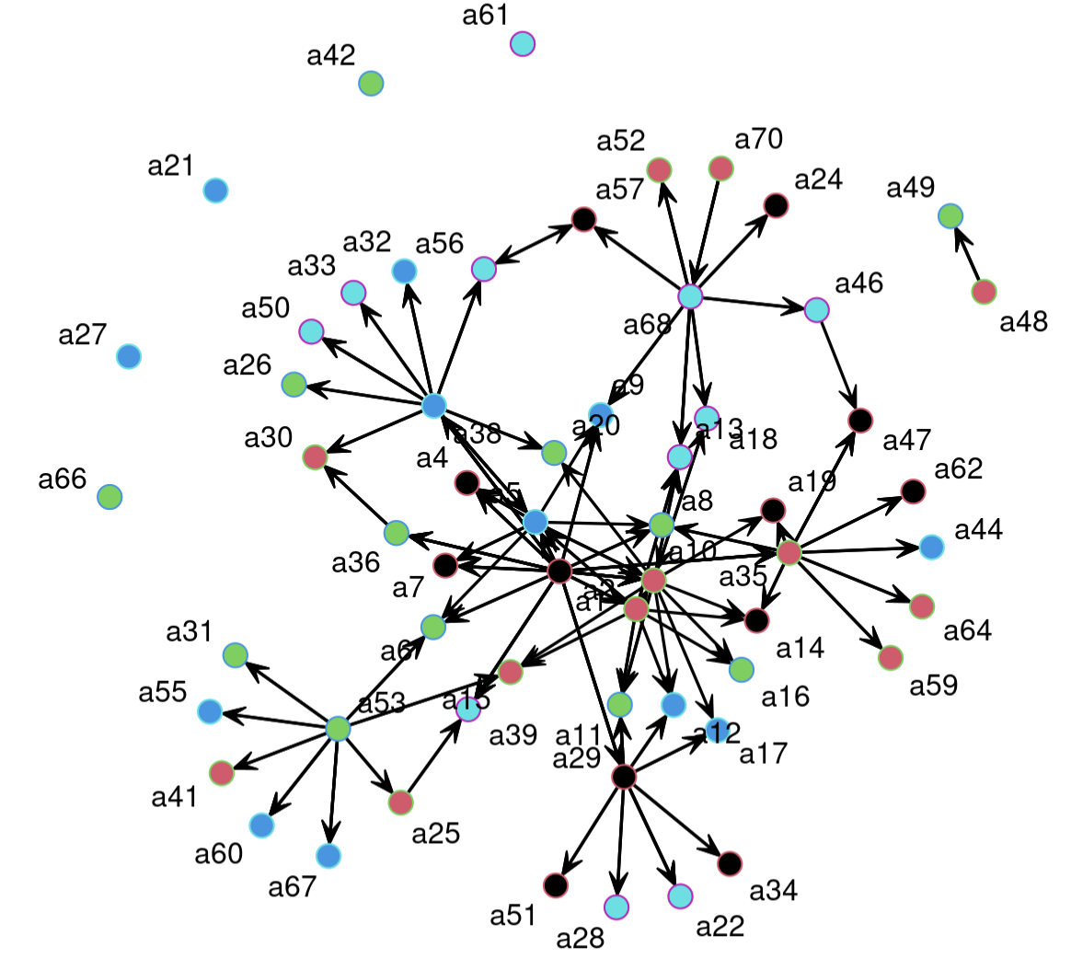

The Advice network has a far more distributed network compared to the Working and Friendship networks, leading to a more drastic change in the structure of the network when removing cutpoints. Six cutpoints were removed from the network and resulted in the outermost nodes becoming isolated.

**Network Bridges**

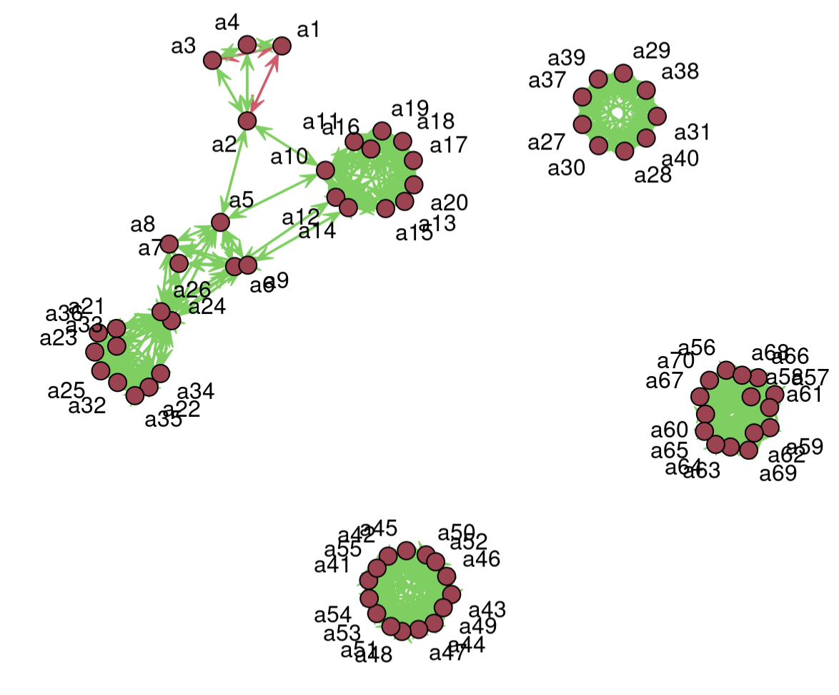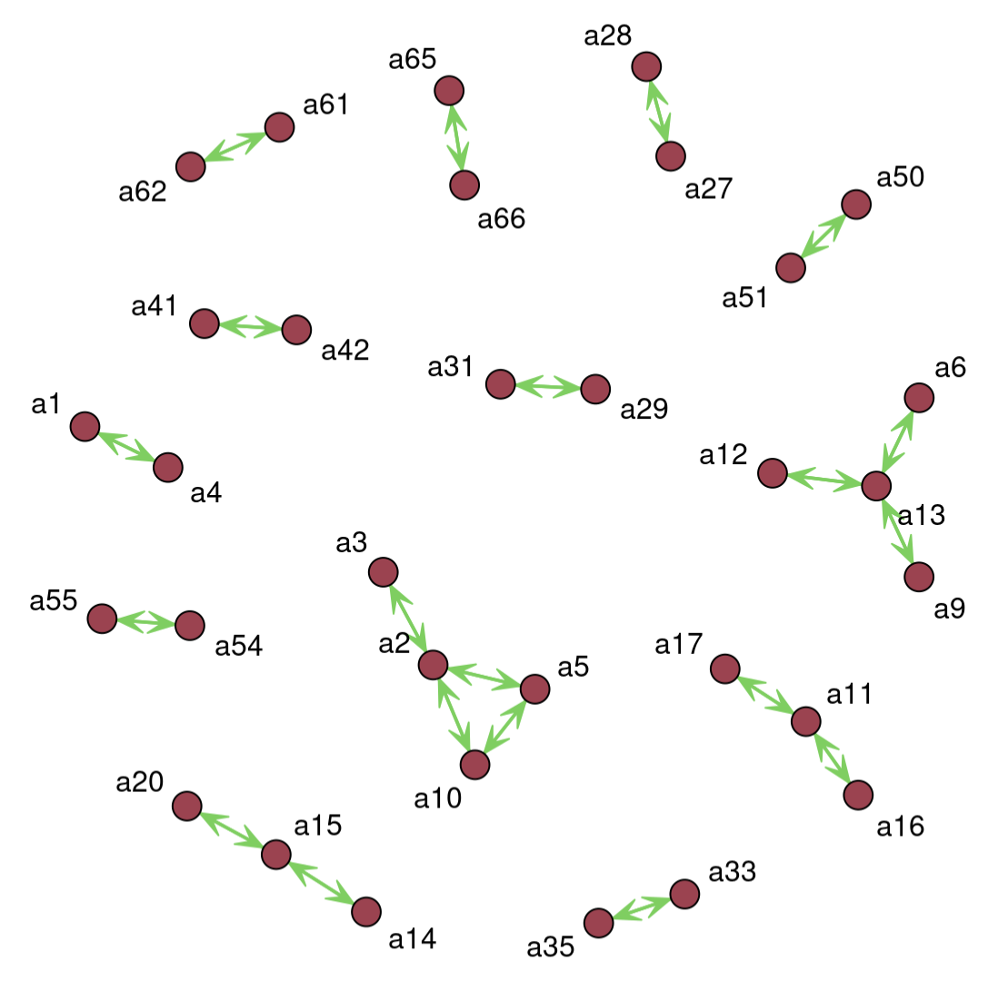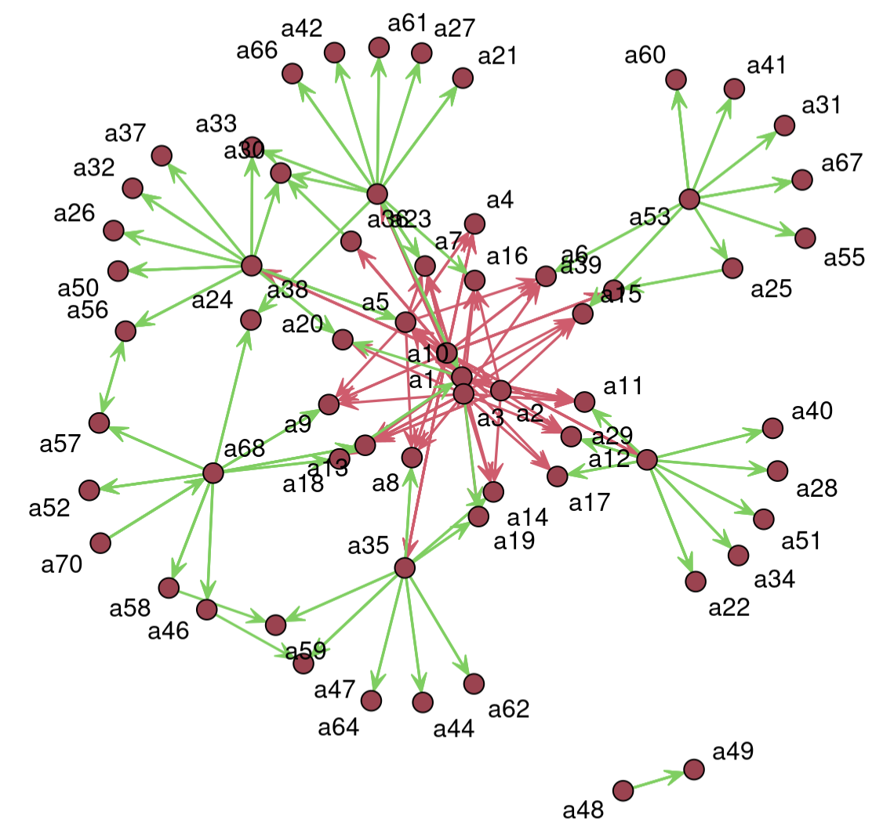

The bridges of the network serve as the cutpoints of the edges. They showcase the connections between nodes that hold the most structure within the network. The Working network shows bridges to the removed cutpoint that was removed. The Friendship network shows no bridges as the network is not dense and has low connectivity. The Advice network shows several bridges in the center of the network with the employees giving the most advice having the highest number of edges.

## Clique Analysis

A clique in a network is a maximally complete subgraph where every node is directly connected to every other node within the subgraph. It represents a subset of nodes that have all possible ties among them. In this network analysis, the vertices represent employees, and in order to visually distinguish them based on their attributes, the network is plotted with vertex labels colored according to their respective attributes.

**Advice Network: Seniority Attribute vs Clique Analysis**

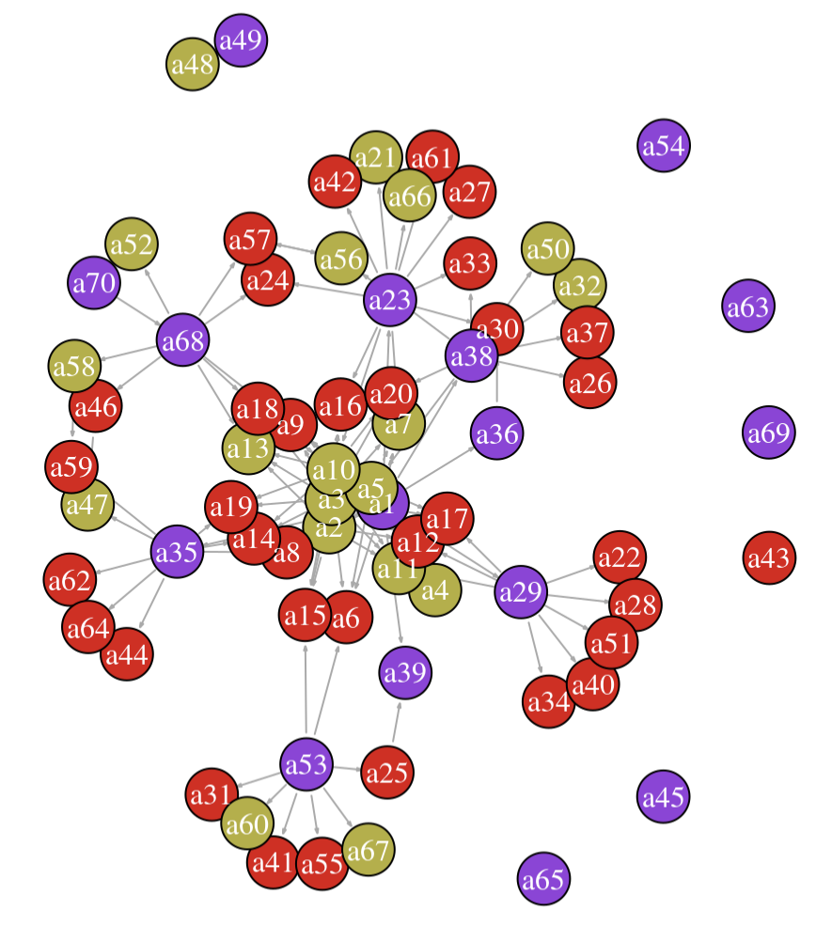

The Advice network has data on which employees share advice with other employees. In order to analyze the accuracy of the clique identification, the graph has been coded by the attribute Seniority, which ranges from 0-2 and indicates how the employee is positioned in the company with 0 being entry level (red) , 1 being Junior level (gold), and 2 being senior level (purple). Seeing as the mentorship program provides employees with lower seniority a mentor with higher seniority, it should be a strong predictor of cliques.

When performing clique analysis, the top three cliques were the following:

1. a10 a1 a5 a3
2. a23 a1 a10
3. a7 a1 a23

The highest ranked clique contains the members at the center of the graph which have top seniority. This is true for the other two top cliques, and the resulting schema of the network where senior level employees often mentor junior employees, who in turn mentor entry level employees.

**Working Network: Department Attribute vs Clique Analysis**

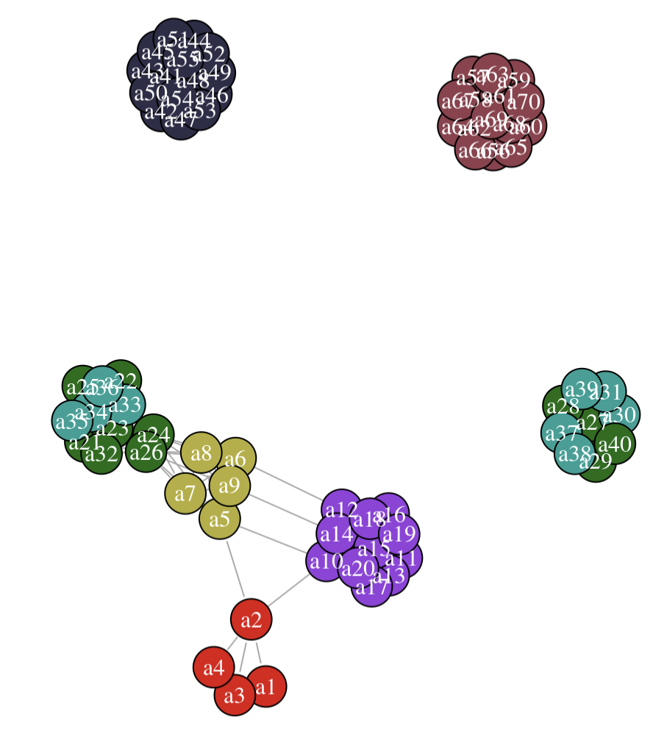

Similar to the selection of attribute for analysis, the working network cliques were compared to the Department attribute which makes logical sense as most people work mainly within their own department. The graph shows all 7 departments: Executive (red), Marketing (gold), Sales (purple), Human Resources (black), Distribution (brown), Manufacturing (green), and Finance (blue).

The clique analysis showed the following cliques:

1. a42 a41 a55 a54 a53 a52 a51 a50 a49 a48 a47 a46 a45 a44 a43
2. a70 a56 a69 a68 a67 a66 a65 a64 a63 a62 a61 a60 a59 a58 a57
3. a10 a11 a20 a19 a18 a17 a16 a15 a14 a13 a12
4. a32 a21 a36 a35 a34 a33 a26 a25 a24 a23 a22
5. a31 a27 a40 a39 a38 a37 a30 a29 a28
6. a6 a12
7. a9 a14
8. a7 a5 a26 a24 a9 a8 a6
9. a2 a5 a10
10. a1 a2 a4 a3

These cliques show a strong correlation between the Department attributes and the clique formation. Outside of a few non-department connections, the clique groupings match the departments. It can be seen that there are inter-department liaisons that transfer work, specifically between Marketing and Sales, and between Marketing and Manufacturing. These relationships are shown by the cliques 6, 7, and parts of 8.

Due to the lack of interconnectedness of the friendship network, no clique analysis was performed.

## K-Core Analysis

In network analysis, the k-core is a variation that addresses the rarity of cliques in observed social networks. A k-core is a maximal subgraph where each vertex is connected to at least k other vertices within the subgraph. Unlike cliques, k-cores offer several advantages: they are nested (each member of a higher k-core is also a member of a lower k-core), they do not overlap, and they are easy to identify. To understand the k-core structure in the network, the graph's density is calculated, representing the ratio of the actual number of edges to the largest possible number of edges in the graph, assuming no multiedges are present. The density value provides an indication of how interconnected the network is. The graph.coreness function is then utilized to identify the k-core structure in the network. It returns a vector that lists the highest core each vertex belongs to in the network.

**Advice Network**

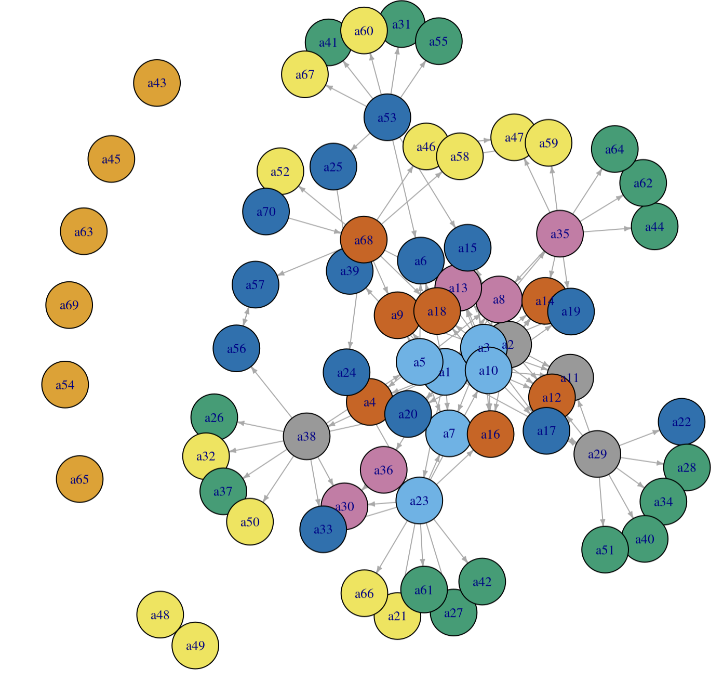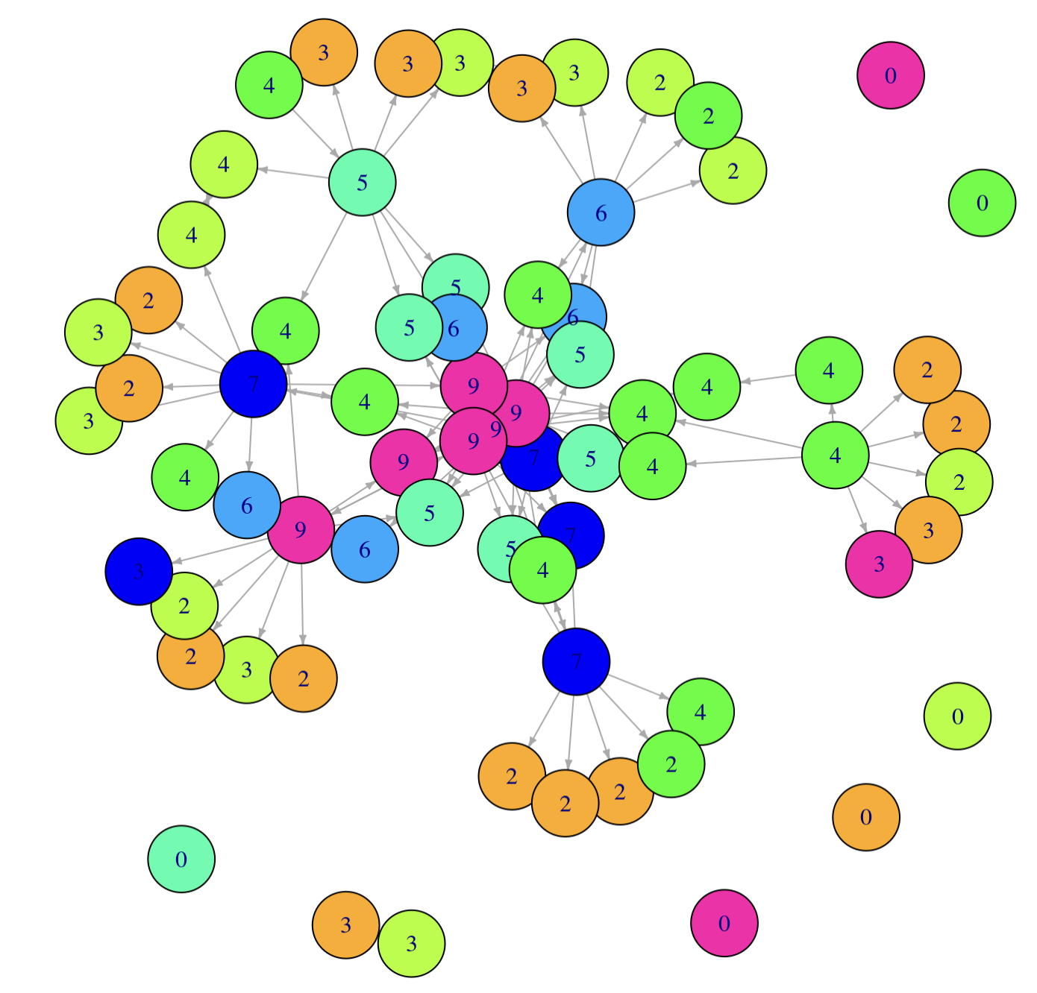

The graph on the left shows the Advice network, classified by the structure of the network, and the graph on the right shows the network, color-coded by coreness, where the k-core is labeled and shows how the center of the graph is more highly connected, compared to the edges. The density of this network is only 0.051, with 9 cores identified.

**Advice Network k-core Decomposition**

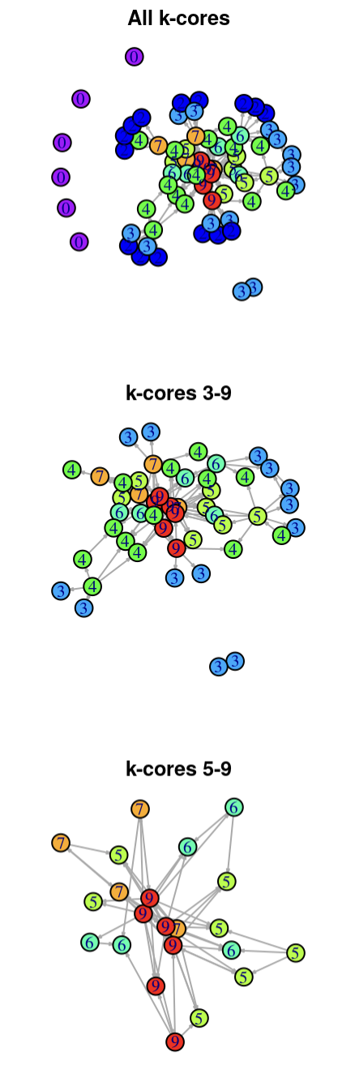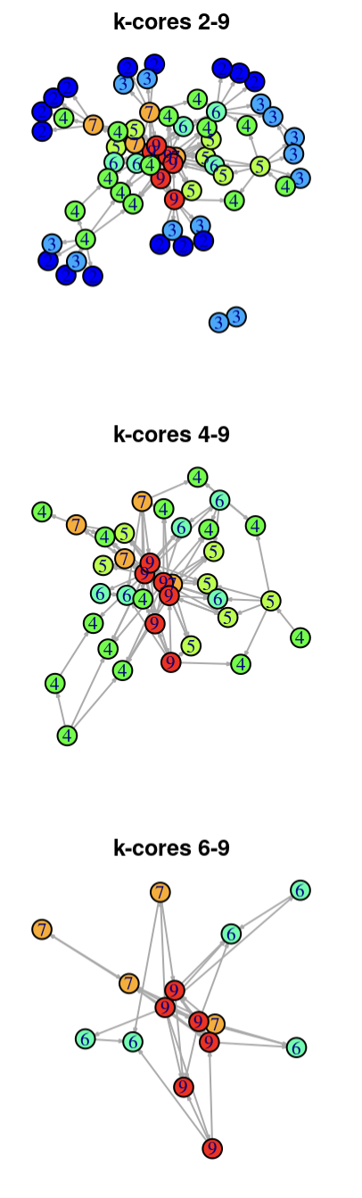

The graphs above show the elimination process of the Advice network cores. The graphs display only the removal of the first 6 cores, as the rest of the decomposition shows no new information about the structure of the network. The breakdown of the network strips off the outer nodes of the network revealing the highly connected nodes at the center.

The nodes with the highest level of connectivity are the mentors of the company and show how the advice flows from the center-most nodes out to the entry level employees.

**Working Network**

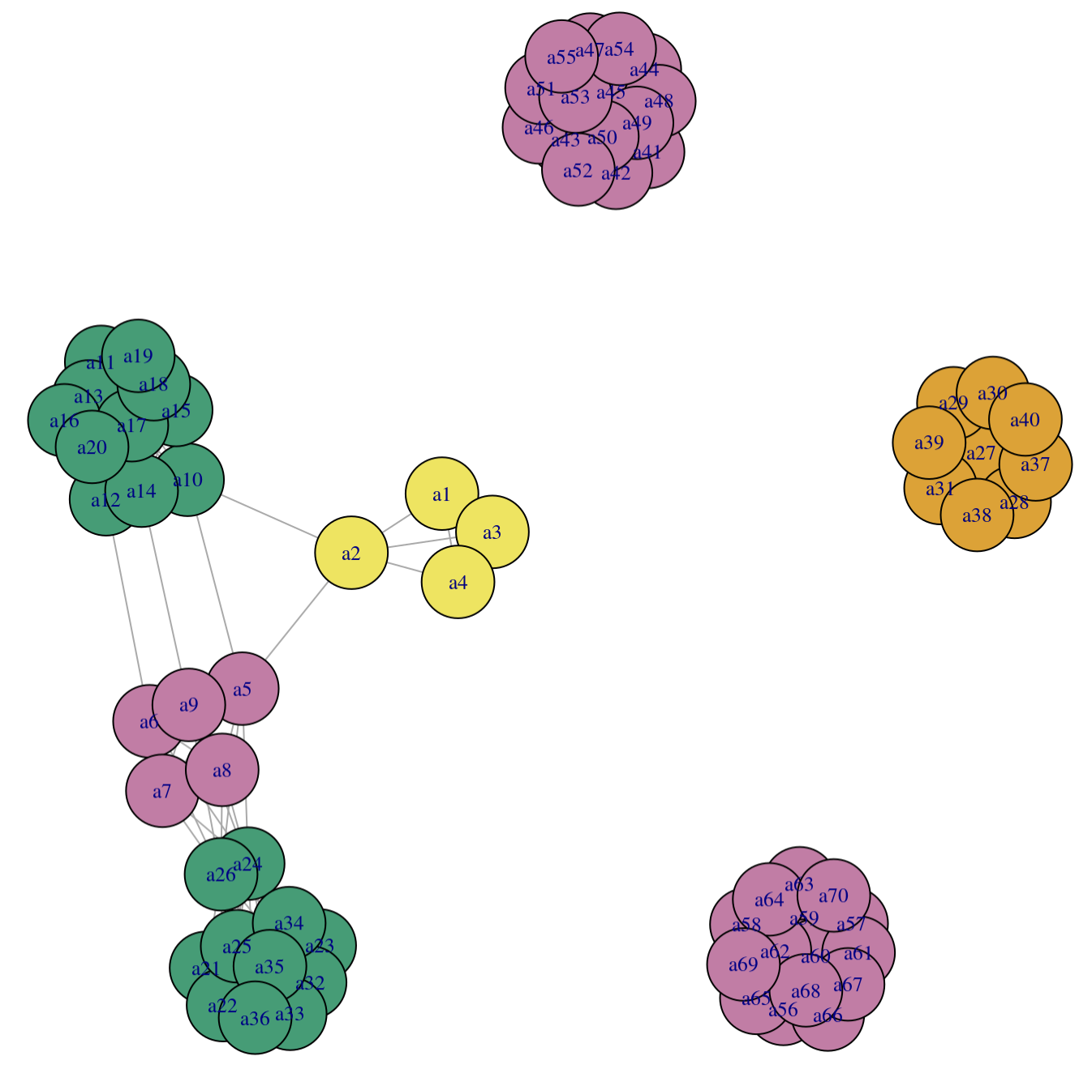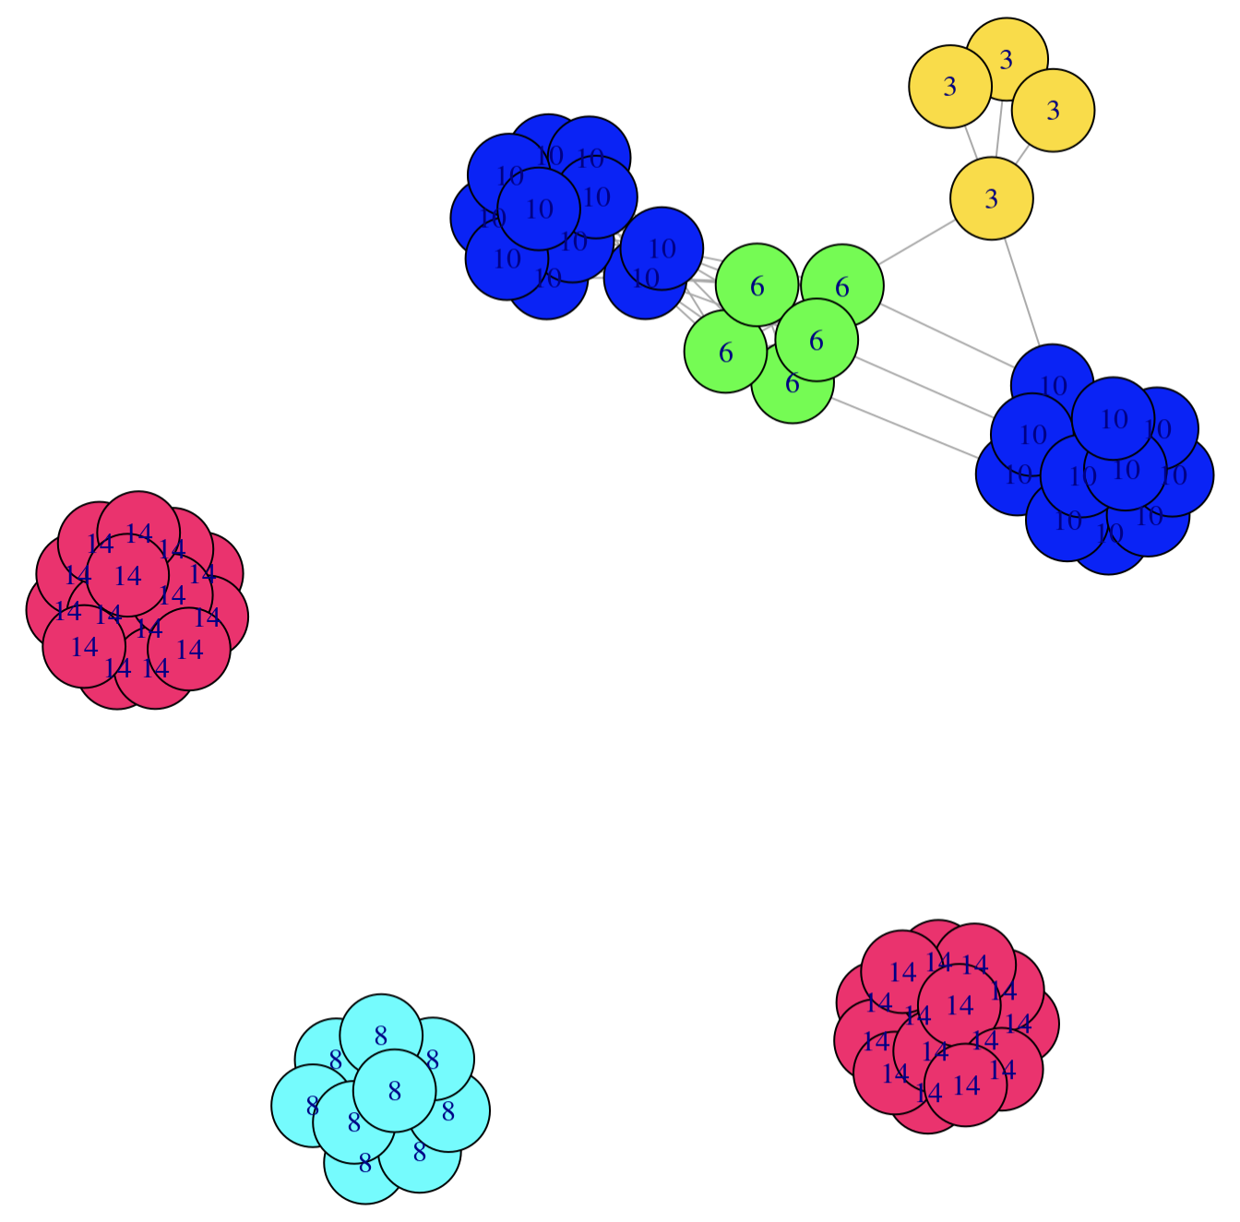

The Working network has clusters of highly connected subgroups that have a density of 0.160 and 14 cores. The subgroups are so tightly packed that analyzing their core decomposition would not yield any specific knowledge about the working subgroups of the company. This makes logical sense for the analysis of the working network because, unlike advice which spans over several departments, the working network is more contained to isolated subgroups.

## Modularity And Community Detection

Modularity is an essential characteristic of networks that plays a significant role in many community detection algorithms. It measures the structural properties of a network, specifically focusing on the degree of clustering observed within groups of nodes and the density of connections between these groups. Modularity provides a chance-corrected statistic that helps quantify the extent to which nodes form clusters that are denser internally and sparser externally.

**Advice Network: Seniority**

When analyzing the Advice network’s modularity, four different algorithms were used: Cluster Walktrap, Edge Betweenness, Label Prop, and Infomap. Each algorithm produced a different modularity score: 0.02144107, 0.4510999, 0.3336058, and 0.1776159. Due to the low value (not close to 1) it can be concluded that across multiple algorithms this network, with respect to the seniority attribute exhibits low clustering. This means the interconnectedness of the network obscures any clustering that would be explainable by the attribute of seniority. This is counter to the logical assessment of the network where levels of seniority would depict network substructures due to how the mentorship program was run.

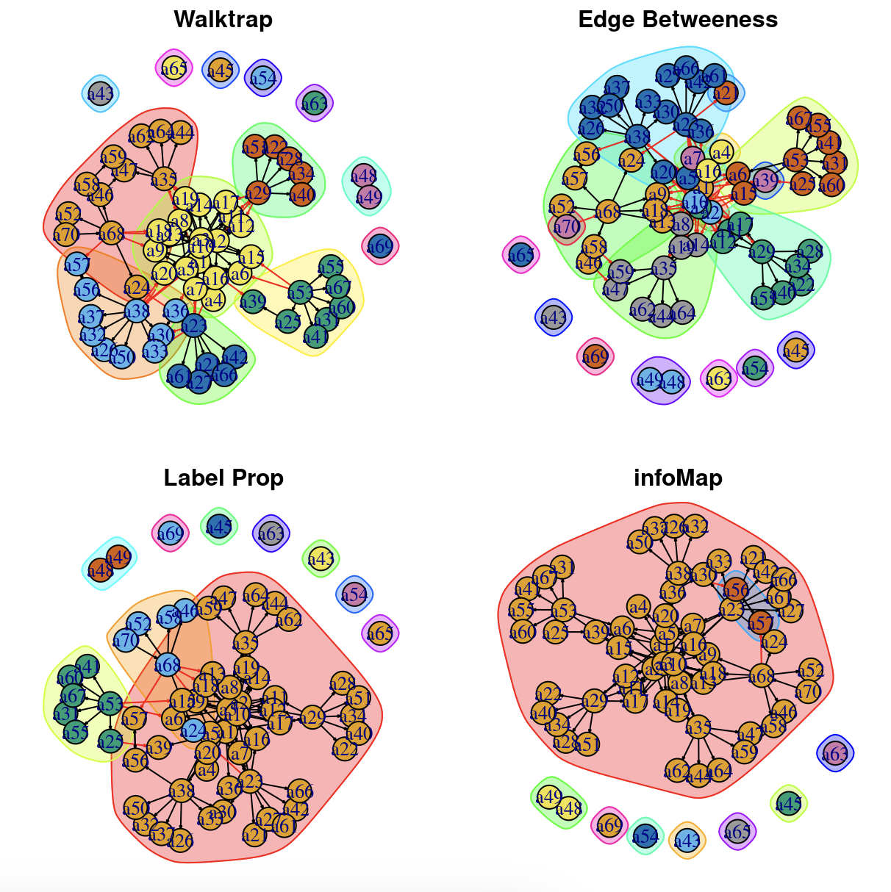

These graphs show clustering performed by the algorithms on the network in regards to the seniority attribute. The Edge Betweenness graph had the highest modularity score, but still does not capture the majority of the seniority subgroupings. Both the Walktrap and the Edge Betweenness algorithms pick up on the branching behavior of the network, with entire branches of the Advice network being clustered together. This would make sense as it defines how the advice flows from the center of the graph, out to a sub-layer, and then finally being distributed to the outer edge of employees. The Label Prop and infoMap algorithms seem to only capture the isolates on the edge, and the center-most cluster of nodes.

## Summary

Overall, when looking at the Advice, Working, and Friendship networks, there are clear characteristics of the structure of the networks, with a strong story being told by the advice network in relation to the seniority attribute. While there is not enough numeric evidence to support clear subgroups, the clique analysis showed how seniority was a strong predictor of clique formation, with cliques being formed around senior-level employees. The k-core analysis added more weight to the number of edges of the network, showing how the center of the network held the most connections, radiating out to spread advice to the outer nodes. The Working network had a clear and transparent set of subgroups, explained almost entirely by the department that the employees worked in. The interconnectedness of these groups was shown by the cutpoints and bridges, where liaisons in the executive department worked with marketing and sales. Lastly, the weakest analysis was drawn from the friendship network, which lacked the interconnectivity to draw numerical conclusions about the subgroups of the network.

The subgroups of this company are strongest within the working network, and weakest within the friendship network. In order to strengthen the understanding of the communities within the company, further data on their attributes should be collected in order to understand how their work, advice, and friendship can be classified into groups. There is a clear distinction between department work, and a lack of friendship groups. A cross-team sport, or project may help to strengthen these subgroups and push deeper interactions within the company. These kinds of interactions are important to strengthening the resilience of the company by creating stronger sub-teams that may be better at things like problem solving, creative ideation, and building rapport among co-workers.